

C:\Users\User\AppData\Local\Microsoft\Windows\INetCache\Content.MSO\BA3C684D.tmp

**Company New Project Location Detector**

|  |  |
| --- | --- |
| **GROUP NAME:** | IMPOSTER MIND |
| **GROUP MEMBERS:** | 195997 TAN SEAN LENG  198879 HALIZA AZZAFIRAH BINTI ABDUL HALIM  198989 ADILAH BINTI ADI YASRAN  199121 AIMI NAZIHAH BINTI HELWANY HAD  199008 NUR NADIAH BINTI RUSLAN |

Instructor: PROF. MADYA DR. MARZANAH BINTI A JABAR

|  |  |
| --- | --- |
| **CONTENT** | **PAGE** |
| 1. Introduction    1. Purpose    2. Scope | 3  3  3 |
| 1. Requirements | 3 |
| 1. Design and Architecture    1. System Architecture    2. Architecture Diagram       1. Deployment Diagram       2. Package Diagram       3. Component Diagram | 4  4  4  4  5  6 |
| 1. Business model    1. Target customers    2. Required resources    3. Channel    4. Key activities    5. Stakeholders    6. Cost structure | 7  7  7  7  7  7  7 |
| 1. Technological innovation    1. QR code and facial recognition    2. Global Positioning System (GPS)    3. Internet of things (IoT)    4. Wi-Fi (wireless LANs) and Cellular network (2G/3G/4G)    5. Sensors    6. Google Map API | 7  7  8  8  8  8  8  8 |
| 1. Customer perspective    1. Easy to Find Location    2. Less Travel Expenses    3. Save Time | 9  9  9  9 |
| 1. Internal User’s Perspective    1. Early Preparation    2. Prevent Waste of Time | 9  9  9 |
| 1. User Interface    1. Login Interface    2. Sign Up Interface    3. Home Interface    4. Detect Company New Project Interface    5. Notification Centre Interface | 10  10  11  12  13  14 |
| 1. Conclusion | 14 |

**TABLE OF CONTENT**

1. **INTRODUCTION**
   1. **PURPOSE**

The purposes of our “Company New Project Location Detector” project are as follows:

* To notify the internal users when external users are near to their company new project site.
* To help external users to shorten visiting cost
* To notify the external users when they are near to company new project to visit.
* To help internal users of the project prepare themselves if the external users confirm that they will come within expected time.
  1. **SCOPE**

The solutions designed for our “Company New Project Location Detector” project is based on the following scopes:

* + Developing new and secure remote work and collaboration solutions.
  + Investigating future working and collaboration solutions.
  + Overcoming the problem of remote work and collaboration.

1. **REQUIREMENTS**

1. User shall be able to register into application using email and password.

2. Users shall able to sign in into the application using the registered email and password.

3. System shall be able to detect external user location and location of the project construction site.

4. User shall be notified when the user location is 1km to 10km near to the construction site.

**3.0 DESIGN AND ARCHITECTURE**

**3.1 System Architecture**

Company New Project Location Detector Application use three-tier architecture that consists of three separate layers which are presentation layer, application layer and database layer. Presentation layer is the layer presents data to the user and optionally permits data manipulation and data entry, also this layer requests the data form Business layer. Application layer is middle-tier components are not tied to a specific client, they can be used by all applications and can be moved to different locations, as response time and other rules require. Database layer is made up of the DBMS that provides all the data for the above two layers.

**3.2 Architecture Diagram**

**3.2.1 Deployment Diagram**

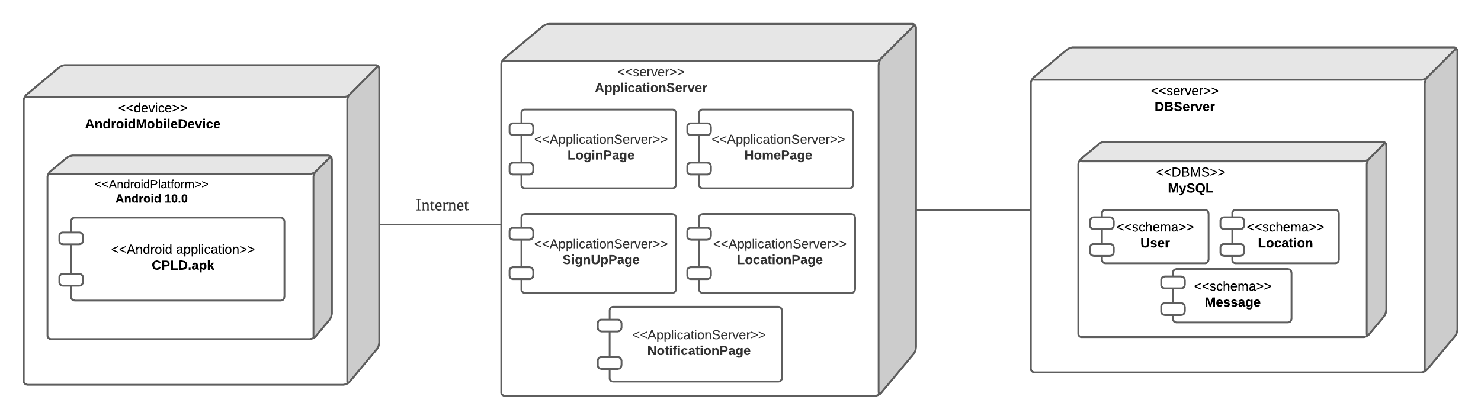

The deployment diagram consists of 3 nodes. Hardware devices used for the first node is Android Mobile Device in order to assess the application server. The platform used compatible for the mobile application is Android 10.0. The user need internet connection to access the application. The second node is ApplicationServer that provide services and networking access to the user. The application server communicates with database server which is the third node to access the data of user, location and message log.

**3.2.2 Package Diagram**

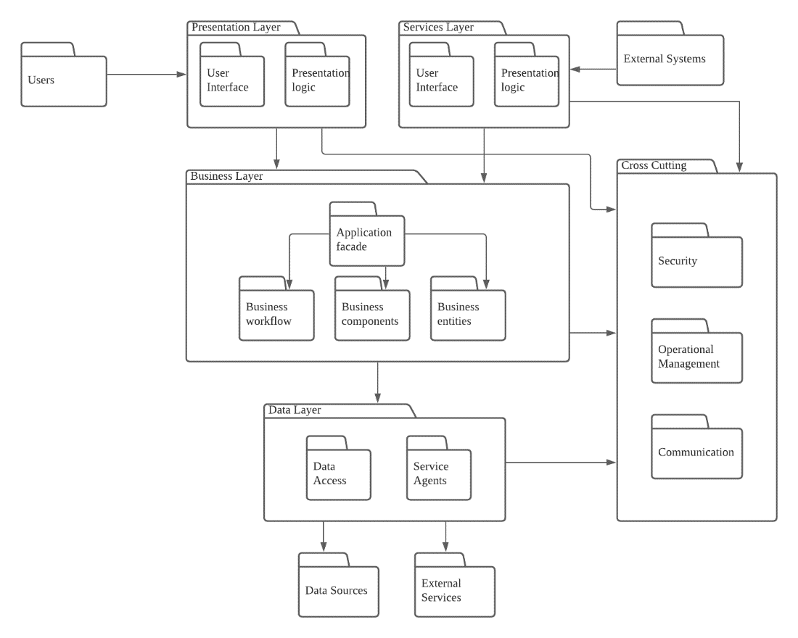

Users package depends on Presentation Layer package while External System package depends on Services Layer package.

There are dependencies between Presentation Layer and Business Layer, Presentation Layer and Cross Cutting, Services Layer and Business Layer, Services layer and Cross Cutting, Business Layer and Data Layer, and Business Layer and Cross Cutting.

Data Layer package depends on external packages which are Data sources and External Services.

**3.2.3 Component Diagram**

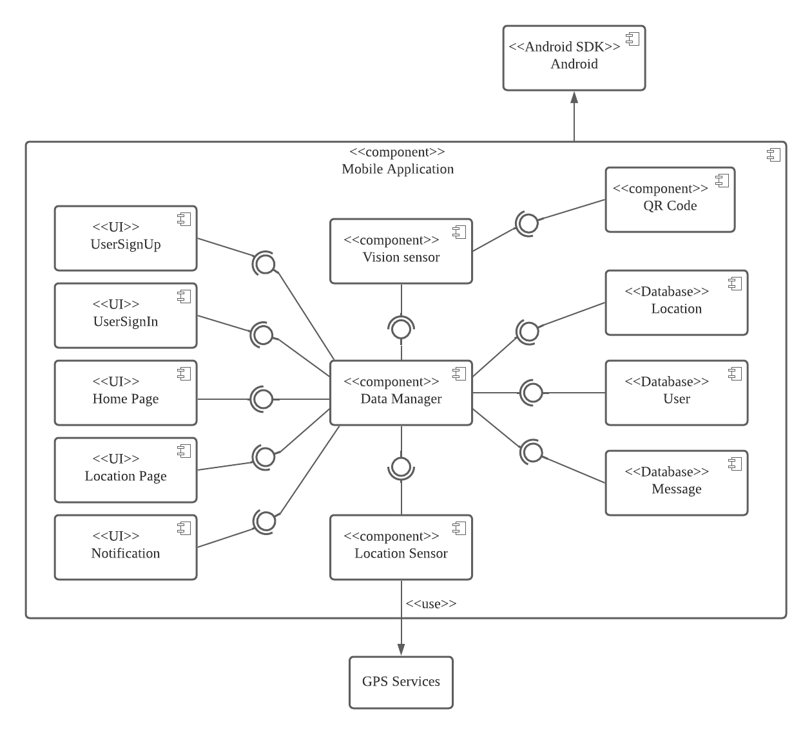

The component diagram has AndroidSDK Android to interact with Mobile Application component. The Mobile Application component consists of user interfaces components such as UserSignUp, UserSignIn, HomePage, LocationPage and Notification. Location Sensor component use GPS services to track user’s location. Vision Sensor has QR code component to recognize users. Databases involved include Location, User and Message.

**4.0 BUSINESS MODEL**

**4.1 Target customers**

* Construction workers
* Engineers

**4.2 Required resources**

* This project business operates databases that are very useful to contain information and location of places.
* Branding and user communities are also the required resources of this project business.

**4.3 Channel**

* Website for advertisement
* Deploy the application through google store and app store

**4.4 Key activities**

The key activities of this business are:

* To ease users in finding new company project sites
* To shorten visiting cost of external user (outside worker)

**4.5 Stakeholders**

* HILTI

**4.6 Cost structure**

The cost of this project business includes:

* The marketing advertisement to attract user
* The salaries of employers such as software engineer and designer.
* The server and framework for this mobile application

**5.0 TECHNOLOGICAL INNOVATION**

**5.1 QR code and facial recognition**

* QR code is use to authenticate the users by scanning the employment card using the vision sensor.
* Facial recognition also helps to identify the user to make sure the face is same with the employment card.

**5.2 Global Positioning System (GPS)**

This project uses a smartphone’s

* GPS technology to track a location of user, if the user has allowed it.
* GPS can offer accuracy of tens of kilometers to the nearest places.

**5.3 Internet of things (IoT)**

IoT can be used to increase operational efficiency with remote monitoring and equipment management, IT infrastructure, enhanced security by enable intrusion detection system and protection of remote sites.

**5.4 Wi-Fi (wireless LANs) and Cellular network (2G/3G/4G)**

Both Wi-Fi and cellular network offer the location accuracy in the order of ten kilometers

**5.5 Sensors**

In supporting high-accuracy, ubiquitous, indoor and outdoor locations, sensors have been described as a key element. It will allow consistent performance across a variety of different environments, combined with GPS, Wi-Fi, and other technologies.

**5.6** **Google Map API**

Google Map API is used to integrate and collaborate between the application and the companies’ location, so that if a new company project is detected by the application, the location will be shown on the map.

**6.0 CUSTOMER PERSPECTIVE**

**6.1 Easy to Find Location**

External users can find nearest construction site easily by receiving notification.

**6.2 Less Travel Expenses**

External users can save fuel and money.

**6.3 Save Time**

External users can arrive to desired destination at expected time.

**7.0 INTERNAL USER’S PERSPECTIVE**

**7.1 Early Preparation**

Internal user can do early preparation if they get confirmation that the external user will come to their company new project site within the expected time.

**7.2 Prevent Waste of Time**

Internal user can avoid wasting time when external user has cancelled the visit to their company site.

**8.0 USER INTERFACE**

**8.1 Login Interface**

Firstly, a registered user needs to log in into the system by using confidential username and password. Once the user successfully logged in, the system will redirect the user into the main page of the system, while if the user enters wrong username or password, the user cannot enter the system and “Wrong Username and Password” message will be displayed.

**8.2 Sign Up Interface**

First of all, an unregistered user needs to sign up first if he or she does not own an account in the system. Once the user had registered successfully by filling up the confidential username, email, password and type of worker correctly, he or she will be redirected to the home page of the application and the data will be saved into the database of the system.

**8.3 Home Interface**

The home page will be shown after the registered user had logged in or signed up into the system. In this interface, the user needs to locate his or her current location by tapping the "location" icon, the user needs to turn on their GPS location sensor so the system can access to their location easily. After that, the user needs to adjust the desired search radius which range from 1 to 10 km. Once the user has finished the above operation, user need to tap the "Search" button and the system will search for the nearest Hilti’s projects location within the searched range. Then, the user will be redirected to the result page.

**8.4 Detect company new project interface**

The result page will show the result of the nearest Hilti’s projects that had been detection within the desired range in this interface. If a company with new project related to Hilti’s technology has been found within the searched radius, the company site will be detected and shown in the Google map of the user’s mobile phone.

**8.5 Notification Centre Interface**

If a company with new project has been found within the searched radius, a notification will be popped up in the notification center.

**9.0**  **CONCLUSION**

In conclusion, Company New Project Location Detector is an application which is designed to help users to discover new company projects near the users’ locations with collaboration among the companies. This application would collaborate effectively among companies in improving future and remote work and collaboration.